Jackson Roberts

Professor Carter

3 December 2020

My 4-8 Fantasy Football Team

Similar to many young adults who are interested in sports, I am an avid fantasy sports player. Last year, I won my fantasy basketball league, my two fantasy baseball leagues and my fantasy football league. This year I have not been so lucky, having terrible seasons in both basketball and football, and getting upset in the first round of the fantasy baseball playoffs. As the fantasy football season comes to a close, I would like to examine how my team has one four out of its twelve games this year, when it has been the third highest scoring team in the league. It had been a frustrating year, being competitive every week but somehow getting beat every week. This project gave me an opportunity to run a simulation to find out just how unlucky my team was, as an opportunity to make me feel a little better overall about the rough season.

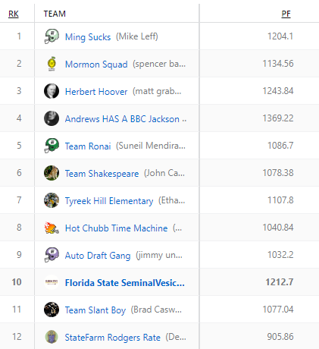 On the right are the current standings in the league, located next to the points scored for each team. My team is in tenth in the standings but my total points scored are the third highest in the league. I scored more points than the top two teams in the league. I decided to simulate the games of the season and predict scores for each team based on the scores that the teams scored each week. After simulating the season one hundred times, I was able to successfully plot the data and find summary statistics based on the results. What I found was that based on my simulation, my team was one of the unluckiest teams in the league during the season. My median win total was 7 but I finished with 4. This makes sense in the world of fantasy sports, where it is impossible to stay consistent, with players underperforming and over performing on a whim and injuries decapitating teams. While I’m disappointed that my team finished so poorly and was so incredibly unlucky, I am relieved to take the burden off my managerial shoulders and hope for some better luck next year.

Spencer

Jimmy

Deven

Brad

**Jackson**

Suneil

Christian

Ethan

John

Soham

Matt

Mike

For this project, I had to manually enter all of the data myself into an excel spreadsheet from our ESPN Fantasy Football website. The datasets were small, making this task only slightly time consuming. I made three datasets. The first had the fantasy scores of each player for each week in the league. The second dataset had all of the matchups with the home team and away team in adjacent columns for each of the six matchups each week. The third dataset had the real life win totals for all of our fantasy teams so they could be compared to the predicted win totals. By creating the datasets, I did not have to change them at all in python. By having these three datasets I was able to predict scores and win totals and compare them with how our teams really performed. I hope this will be a useful tool for all of the owners in our league in the future to see 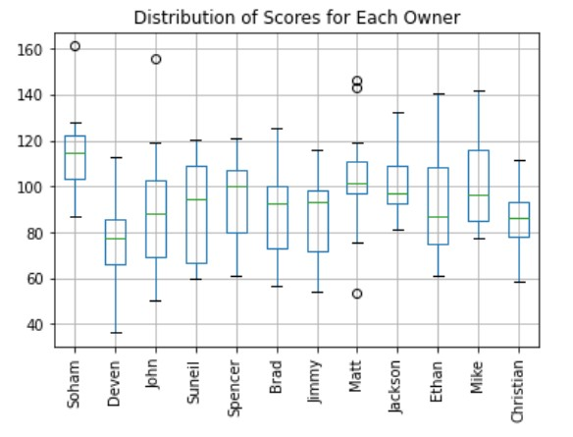what teams are actually good and which ones are pretenders.

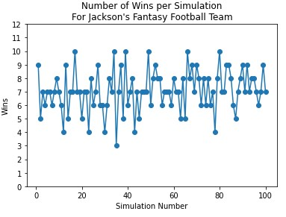 After loading in the datasets I created a boxplot to visualize the spread along with the centers of each person’s scores over the season. My team had one of the highest minimums, which is important for avoiding losses in fantasy football. It is clear that my team was one of the more consistent teams, having one of the smaller ranges in the league. We can see that Matt had three large outliers in his weekly scores, providing the opportunity for more spread out win totals. This plot was a starting point in determining the patterns that I may see in the data as I go on with my experiment. The next step was simulating the season. Using the matchups dataset I was able to use each players mean and standard deviation of their season scores to calculate a score for each team in each matchup during the whole season. I did this by generating random numbers using the normal distribution. I had the code keep track of the winners of each matchup so I could use the numbers to create plots and carry out more calculations. I made line graphs for each player which can be seen in the dashboard. Mine can be seen to the left showing the frequencies of times I had each amount of wins. In six of the simulations I had ten wins but in five of the simulations I only had four wins. This chart shows the variability in fantasy football, as I was one of the more consistent teams and my win total varied greatly. From this it can be 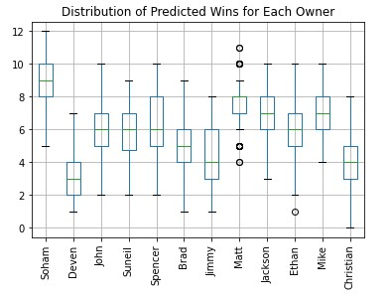seen that my win total should have probably been around seven though which I would have taken as a fair compromise. I again created a boxplot to see the centers and spreads for the predicted wins of each owner during the simulations. My values were again pretty high, with my minimum being the fourth lowest and my median being the third highest. It was interesting to see one of my roommates Soham, have a 12-0 season predicted, while my other roommate Christian had a 0-12 season predicted. The predictor created a wide spread of possible win loss records, which was expected with fantasy football.

While I had some visual evidence of being unlucky, I wanted some numerical evidence to back up how unlucky I was. I decided to use two methods, percentiles and z-scores. I started with percentiles. I was able to calculate the percentile in which each player’s real life score fit in the distribution of predicted scores, or in different words, how many predicted values were less than or equal to the real life win total. The value I calculated for myself was 0.06 putting my season in the sixth percentile of possible seasons I could have had, which is pretty unlucky. Soham also was in the sixth percentile, showing that his season was also unlucky, even at 7-5. My friend Mike fell in the 100th percentile, showing that his season could not have gotten luckier in all of the simulations. I then calculated z-scores to calculate how many standard deviations our real win totals were from our expected win total. My z-score was -2.04, meaning my win total was just over two standard deviations less than the mean. This was a lot greater than Soham’s, whose z score was -1.79. We both had very unlucky seasons using both metrics. Mike and Spencer, the top two teams in the league standings both had z-scores higher than 1.6, meaning that they were very lucky in their win totals. Using percentiles and z-scores, I was able to conclude that my team was incredibly unlucky to finish 4-8 this season. I could have snuck into the playoffs and made a run, but unfortunately I will have to wait until next year.

In conclusion, this was a really fun way to interact with my fantasy football season and see how each team fared over 100 simulated seasons. I would be very interested to replicate this project on my fantasy basketball and baseball seasons to see how the variability changes from football. It would be interesting as well to see how my 7-6 team from last season that won the championship did in terms of luck using this simulation. The idea of luck is such an arbitrary idea and may not even exist, but when looking at the results of my study, it is hard to conclude anything else. My team did not deserve to finish 4-8 but I will have to bite the bullet and hope that I get some of that luck next year to come my way.

To learn more about the project and to see more visualizations, the links to the dashboard and repository are below:

Dashboard: <https://enigmatic-castle-97222.herokuapp.com/>

Repository: <https://github.com/jacksonrobertsbentley/Final-Project-Repository>